Board of Directors
Round Valley County Water District
Dane Downing, Chair
John Marshall, Vice Chair
Robbie Wyre
Sandra Mullen
Bruce Hilbach-Barger
P.O. Box 535, Covelo, CA 95428
707-405-0023
rvcwdmanager@gmail.com

General Manager
Imil Ferrara
Project Manager
Lourance Hall

March 26, 2024

To Whom it May Concern,
On behalf of the Round Valley County Water District (RVCWD) Board of Directors and their constituents, I write to express the District’s unanimous resolution that both dams on the upper main stem of Eel River should be removed, and all diversions from the Eel River watershed should permanently cease.
The RVCWD Board of Directors see removal of water retention and extraction infrastructure on the Main Stem as essential to the long-term health of the Eel River and its endangered salmonid populations. As elected officials charged with managing and protecting water resources and aquatic systems in the Eel River watershed, the RVCWD Board joins the Round Valley Indian Tribes (RVIT) in demanding removal of Scott and Van Arsdale dams and an end to all diversions of Eel River water into the Russian River, as expressed in RVIT Tribal Council Resolution number…
Survival of the Eel River fishery, fundamental to Native life and maintained in abundance for millennia under Tribal care, requires immediate dam removal and permanent elimination of all water extraction from the Eel.
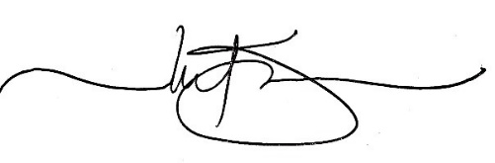

Imil Ferrara, General Manager
Round Valley County Water District

