MEETING OF THE ROUND VALLEY AREA MUNICIPAL ADVISORY COUNCIL (RVAMAC)
Wednesday, April 01, 2026 at 6:00 PM
Library Commons 23925 Howard Street, Covelo, CA
Mailing Address: PO Box 372, Covelo, CA 95428 https://mac.roundvalley.org/ To join Zoom meeting: https://zoom.us/j/2324039636#success
Meeting ID: 232 403 9636 Call In: +1 669 900 6833
For those who are not able to attend by phone or video, you may make public comments at the Library Commons. Public comment is available for all items on the agenda.
Agenda
1. Call to Order & Roll call
2. Approval of April 01, 2026 Agenda
3. Approval of March 4, 2026 meeting minutes
4. Public Comment & Announcements on non-agenda items.
a.
b.

5. Reports from County, State and Tribal officials:
a. Tribal Council
b. Sheriff Kendall
c. Supervisor Haschak
d. Round Valley County Water District
e. Mendocino County DOT
f. MCOG
g. Office of Assemblyman Chris Rogers: Monica Barragan - 2026 List of Bills authored by Assemblyman Rogers
h. Covelo Fire Protection District Report
I. Emily McCobb, U C Davis Covelo Vet Clinic - clinic was in RV March 28 and 29
6. New Business:
6a. Discussion/possible action: Would the RVAMAC be interested in tabling at the Earth Day on April 25, 2026. This is a good opportunity to connect with the community and add to our email listserve.

6b. Discussion/possible action: Recent cell phone outage in the valley and the cell service has decreased substantially in many areas of the valley with many weak-signal or dead spot areas where there was service before the outage .

7. Old Business:
7a. Discussion/possible action: BOS February 24, 2026, meeting, Item C19 on the Consent Calendar. Request for Sup. Haschak to discuss this item and how, if at all, Round Valley may receive grant money for trash abatement:
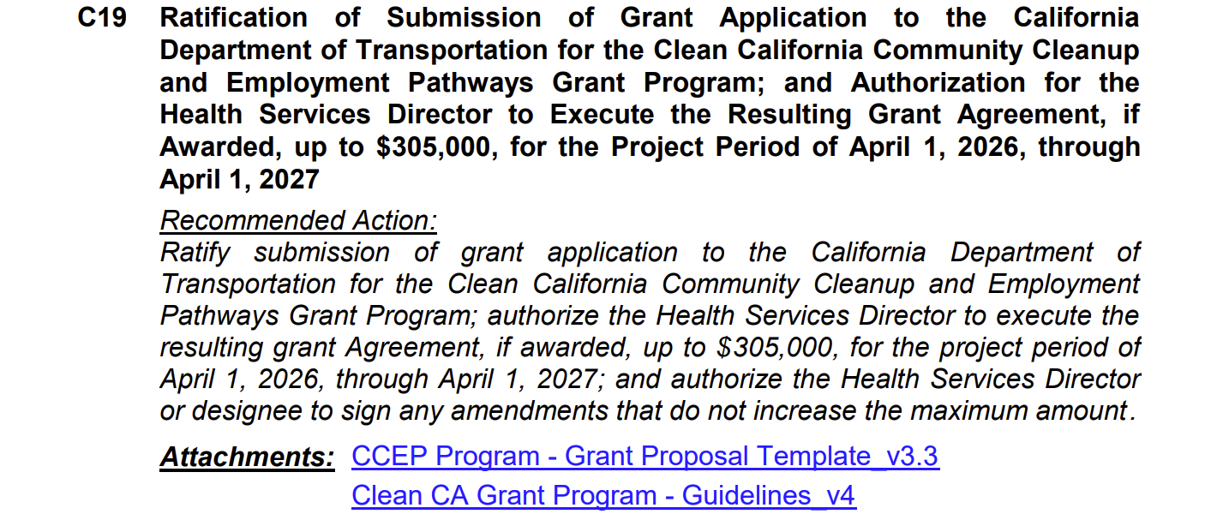

Supervisor Haschak to follow up with DOT to check on plans for the Round Valley area. What were his findings?
7b. Discussion/possible action: developing the Round Valley Area Emergency Operations Plan. Next Round Valley Prepared meeting - April 15, 2026 - 4:00 p.m. - @ the Library Commons.
7c. Discussion/possible action: CalTrans has been invited to provide an update on their Highway 162 projects and address concerns presented by Pat Sobrero. See attachment. (Carried over from December agenda)
7d. Discussion and possible action: development of a county noise control ordinance. Will there be an opening for RVAMAC comments? - (update from Supervisor Haschak)
7e. Discussion and possible action: any needs for the Covelo Fire Hydrant project? Lew Chichester to give a brief update/report on the town fire hydrant project. This item is a work in progress and will remain on the agenda.
7f. Discussion/possible action: possibility of the county creating a safe housing area for deputy sheriff and other essential county employees and health care workers on the Forestry Service property located at the Covelo Ranger Station.
7g. Discussion and possible action: ongoing problems in the community with uncontained dogs, dogs that have been abandoned (dumped), dogs killing other dogs and creating a nuisance and potential safety issue.
7h. Discussion and possible update: Discussion/possible action: Michelle Merrifield has requested to speak about the valleys farm land and fields to have fire breaks or a control burn on dry vegetation. Michelle did draft a letter for the RVAMAC to consider; the letter has been provided to the Covelo Fire Department and the Round Valley Indian Tribes. Unless there is further information or discussion, we will consider dropping this item from the agenda.
7i. Informational: Round Valley Indian Health Center and Round Valley Indian Tribes sponsored a 4 day Emergency Preparedness Training with Falmouth Institute at the Covelo Recreation Center October 14, 15, 16 & 17, 2025. Next steps: Next Round Valley Prepared meeting scheduled at the library commons - , 5:00 p.m.

7j. Discussion/possible action: Clean California Designation Program - Are we interested in starting a campaign in our community to earn this designation? Informational flyer attached. Carried over from December agenda)
https://cleanca.com/designation/
7i. Discussion/possible action: MCOG has been invited to update our community as to its Round Valley Projects as of November 2024. See attachment.
7j. Discussion/possible action: Many unincorporated areas, even Covelo/Round Valley, have their own specific local plans as part of the County's General Plan. Is this a project the RVAMAC wants to participate in? Attachment: Covelo Local Plan 2009
8. Treasurer’s report

9. Next Meeting: May 06, 2026. Send agenda items to:
admin@mac.roundvalley.org.
10. Adjournment

